**Air Ticket Reservation Management System**

**ATRMS**

***Software Development Progress Report – Part 2***

**Abstract**

This document keeps track of the progress of the initial system development phase (Part 2). It includes Use Case Diagram, Case Descriptions, Class Diagram, and finally, client’s comment and suggestions sections.

**Use Case Diagram**

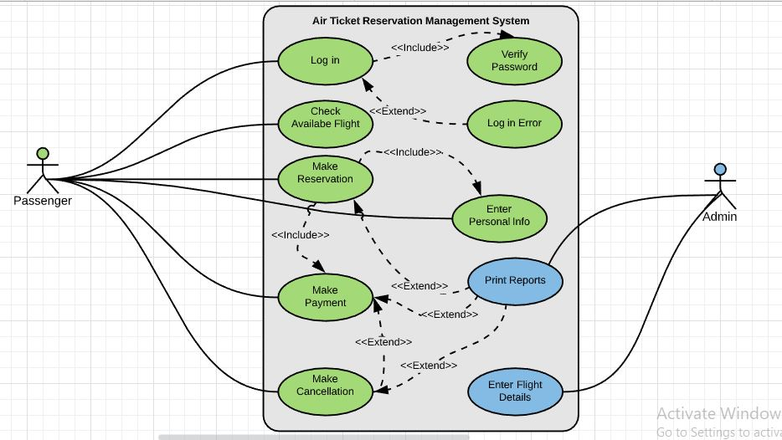

*Fig. Use Case Diagram of Air Ticket Management System*

**Case Descriptions**

**For Actor (Passenger)**

**Login**

Passenger enters username and password to login.

**Verify Password**

It is included in the login use case to verify that the username and the password are correct.

**Login Error**

This case is extended from Login to show error message when the username or password does not match.

**Check Available Flight**

A passenger can check whether a flight is available for his or her destination at a desired date and time.

**Make Reservation**

A passenger can make a reservation for the ticket(s) if he or she finds the available flight.

**Enter Personal Information**

A passenger must enter his or her details when reservation is made. This use case is included as part of make reservation.

**Make Payment**

After reservation, user will be taken to make payment form. This use case is included as part of make reservation, too.

**Make Cancellation**

This use case is extended from Make Payment use case because a passenger can make a cancellation after the payment or maybe not.

**For Actor (Admin)**

**Enter Flights Details**

Admin can perform the CRUD operations to flight details information.

**Print Reports**

Admin may print out the reports of payments, reservations and cancellations. This use case is extended from three use cases, Make Payment, Make Reservation and Make Cancellation.

**Class Diagram**

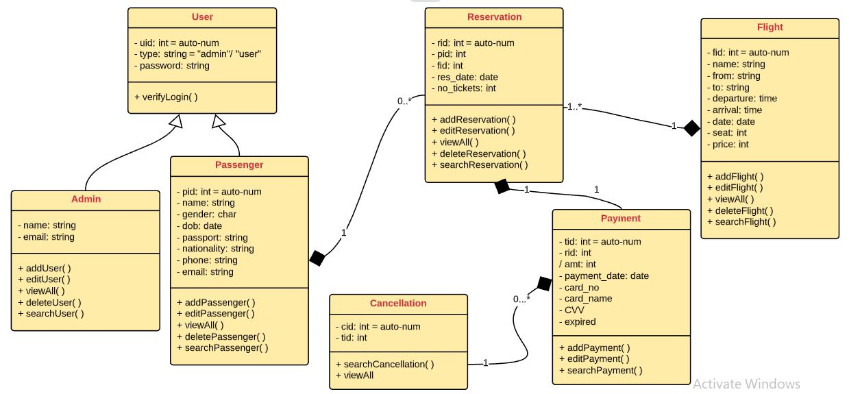

**Client’s Comments and Suggestions Form**

Dear Client,

Please fill up the comments for each section and, suggestions or ideas **(if you have any)** for each section.

**Use Case Diagram**

Comment:

Suggestion:

**Case Descriptions**

Comment:

Suggestion:

**Class Diagram**

Comment:

Suggestion:

Thank you very much for your support on this application development.

Yours Sincerely,

***Myo Thet Tun***

Application Developer

**Micromac Software Inc.**

**Date: 14/02/20**

**Our motto: Software quality is satisfaction of requirements, not goodness.**